Q1How does the latency change as the number of clients change? Does it change for different types of requests?

Q2How does the latency of the lookup requests compare to trade? Since trade requests involve all these microservices, while lookup requests only involve two microservices, does it impact the observed latency?

**We can see that the respond time increase linearly as the number of clients goes up, and since trade request needs to go through one more server, it takes longer time. As is depicted below**

Here shows the response time(in seconds) of sending lookup requests to the frontend server, using one,three five,seven clients(each client keeps sending request in a while loop)

One client

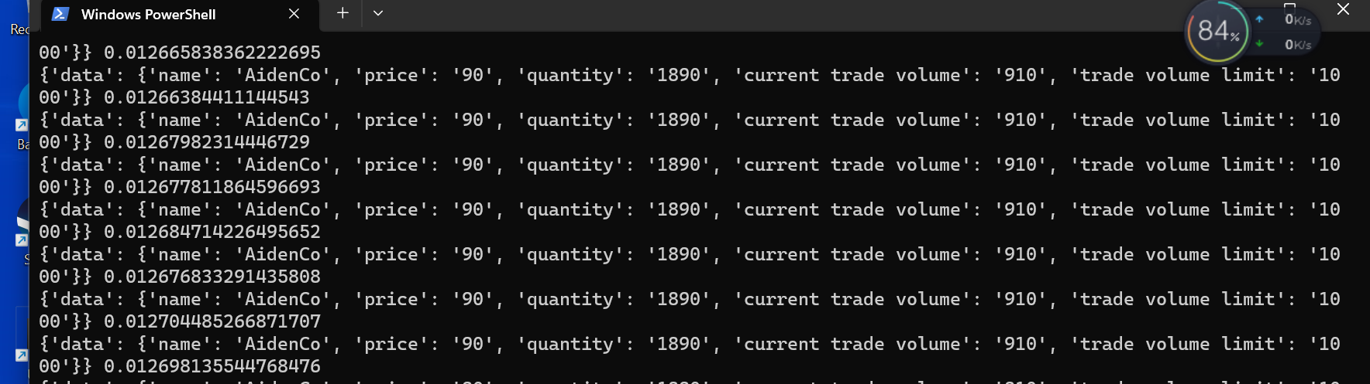

three clients

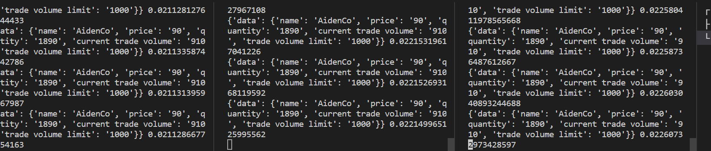

Five clients

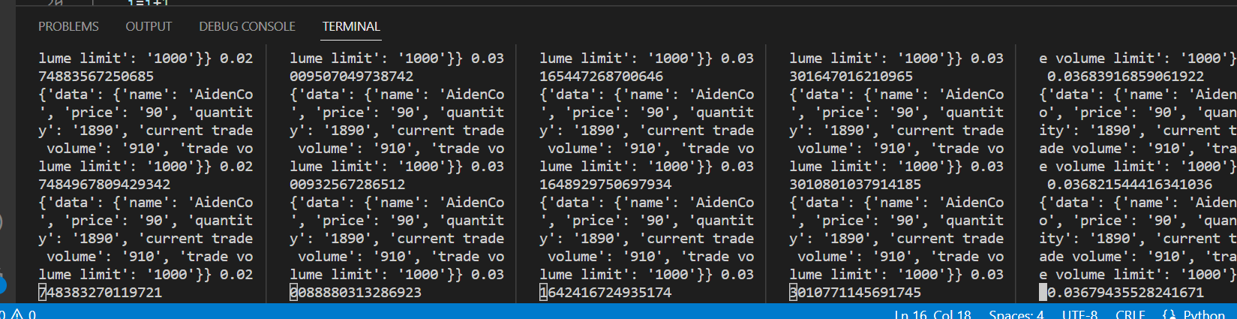

seven clients

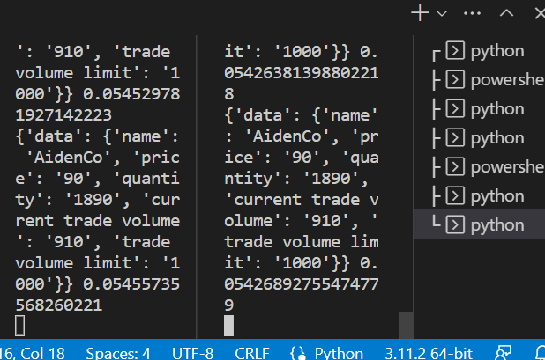

Here shows the response time(in seconds) of sending trade requests to the frontend server, using one, five,ten clients(each client keeps sending request in a while loop).

The result will keep showing the “trade volume reaches upper bound”, that’s because our continuous trade operation. However, that don’t affect our test because the request still go through all three server’s processing and being send back.

One client

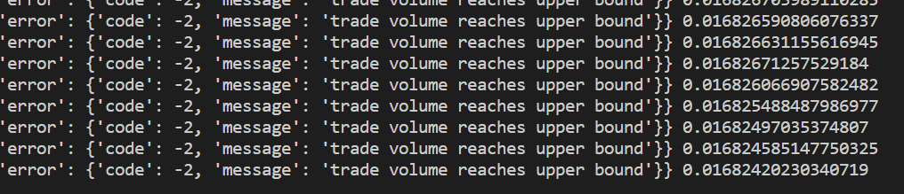

Three clients

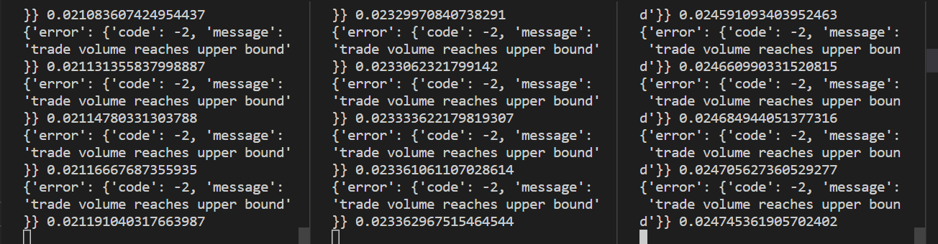

five clients

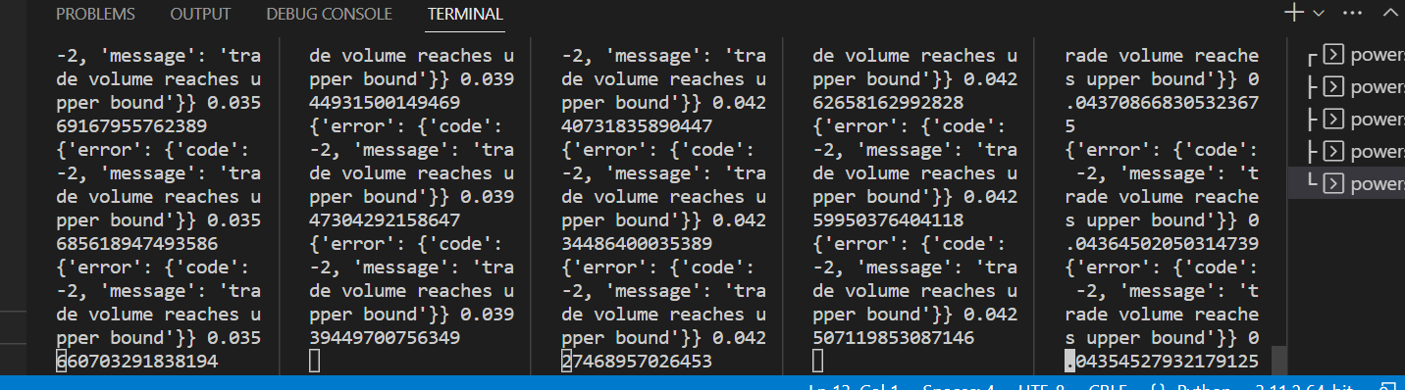

Seven clients

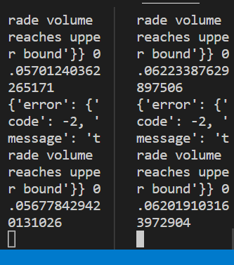

Then we want to know which part becomes the bottleneck of the system, the following picture shows the latency(in microsecond) we get when we have 7 clients send trade requests directly to the order server, we do this because we suspect the python-implemented frontend is the cause, the catalog server and order server are all implemented using c++.

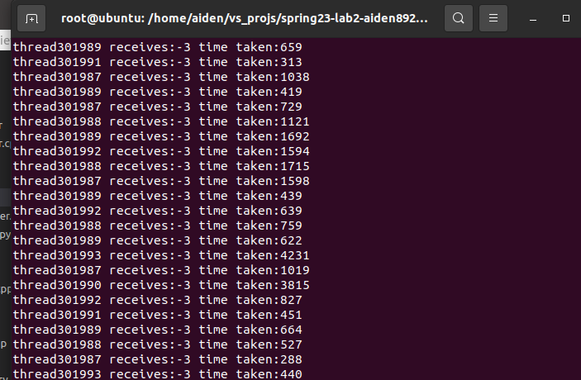

Here the delay are from hundreds of microsecond to a few milisecond,this including processing and transmiting delay in two servers. and we maesured the network delay between client and frontend server using ping, which shows it is less than 1 second.

Thus we can say, among the 50 milisecond delay we witnessed in the above test, the majority of them are incured by the python frontend.

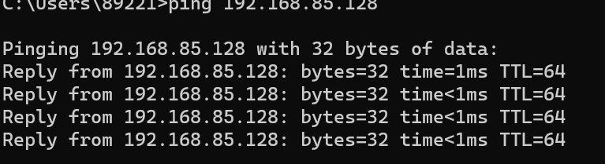

Why is python-implemented frontend server so slow? it is supposed to be multithreaded as well.

Under further research, I found the reason from stackoverflow

